Home - Djadel Hairdressing  
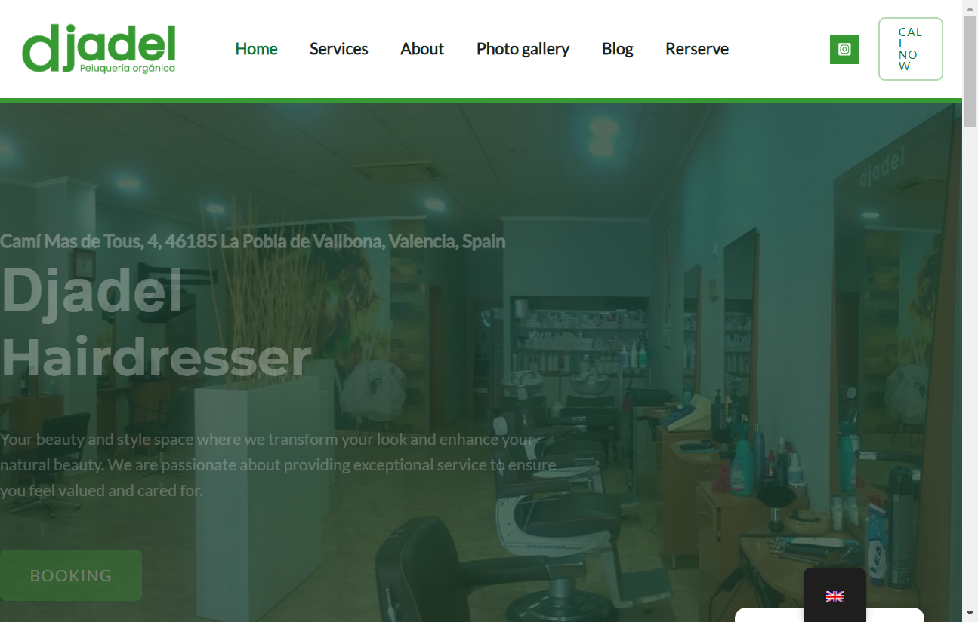

Legal Notice - Djadel Peluquería  
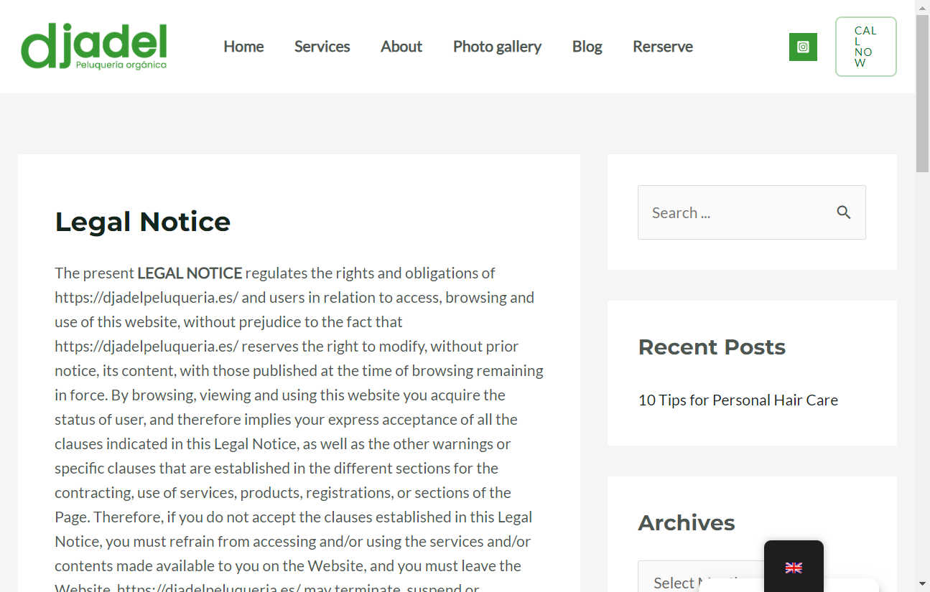

Politica de Cookies - Djadel Peluquería  
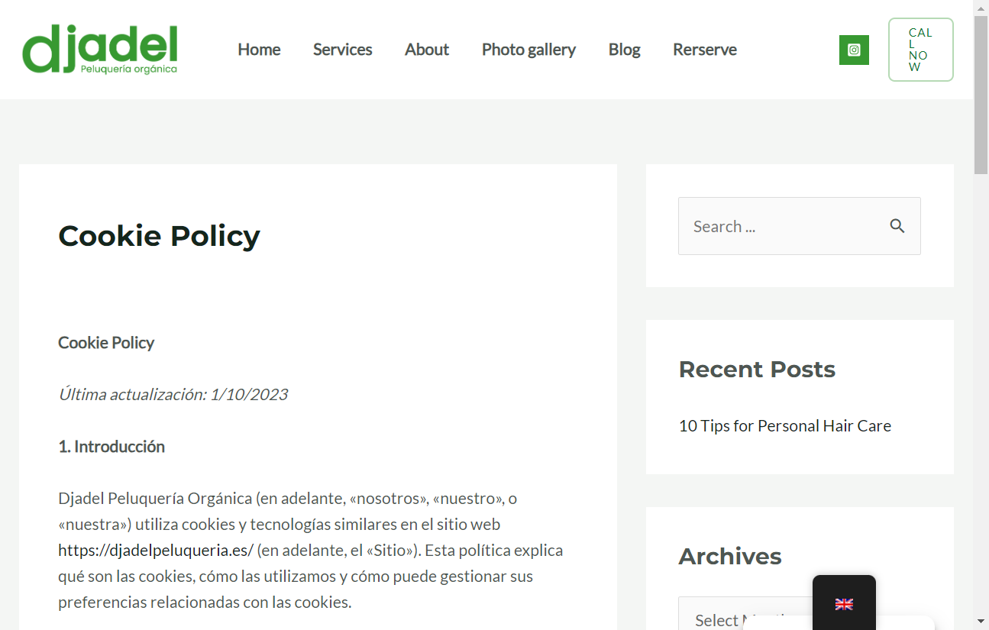

Accessibility - Djadel Hairdressing  
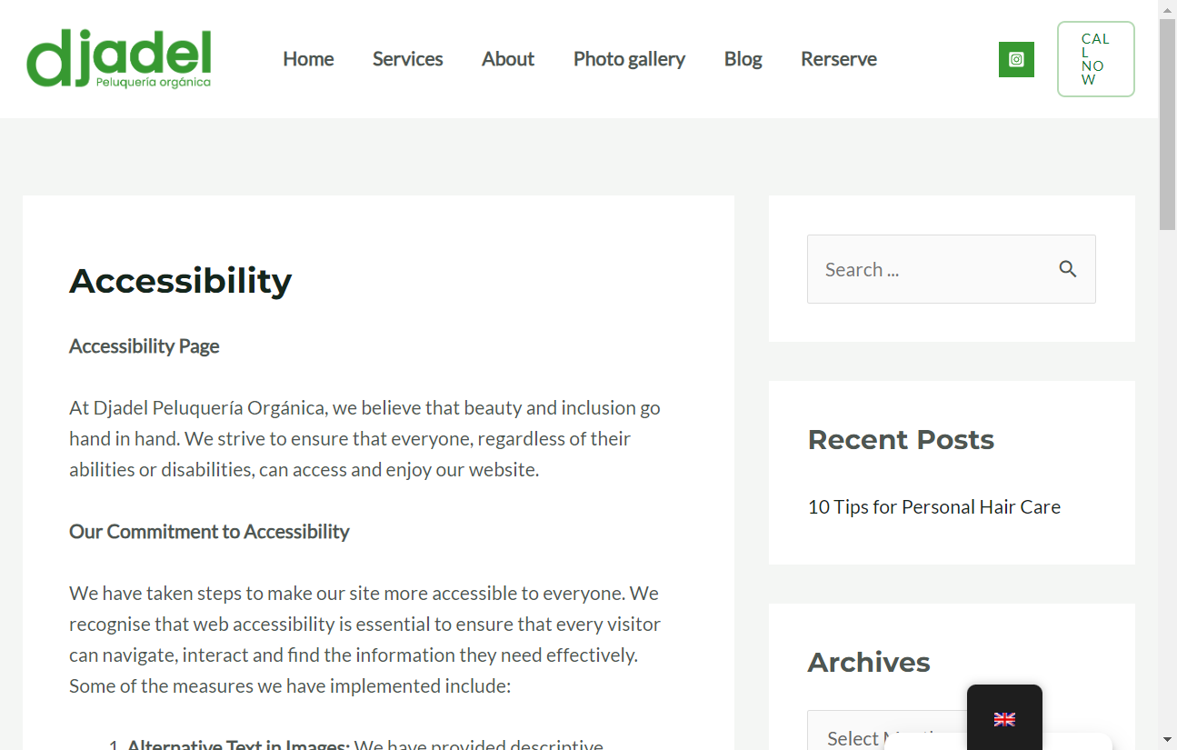

Blog - Djadel Hairdressing  
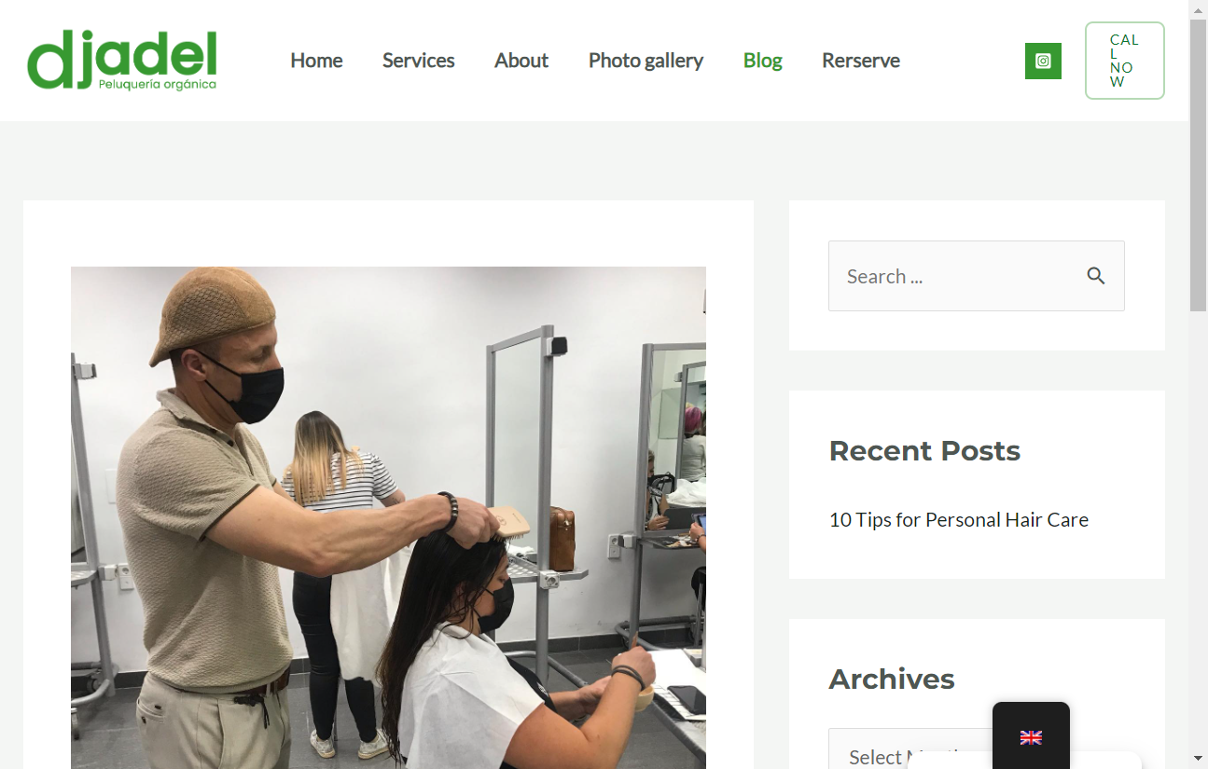

About - Djadel Hairdressing  
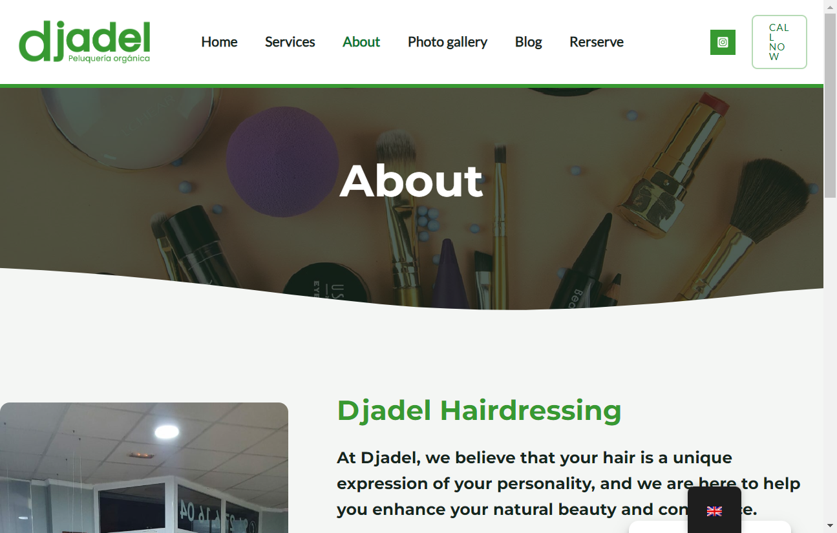

Services - Djadel Hairdressing  
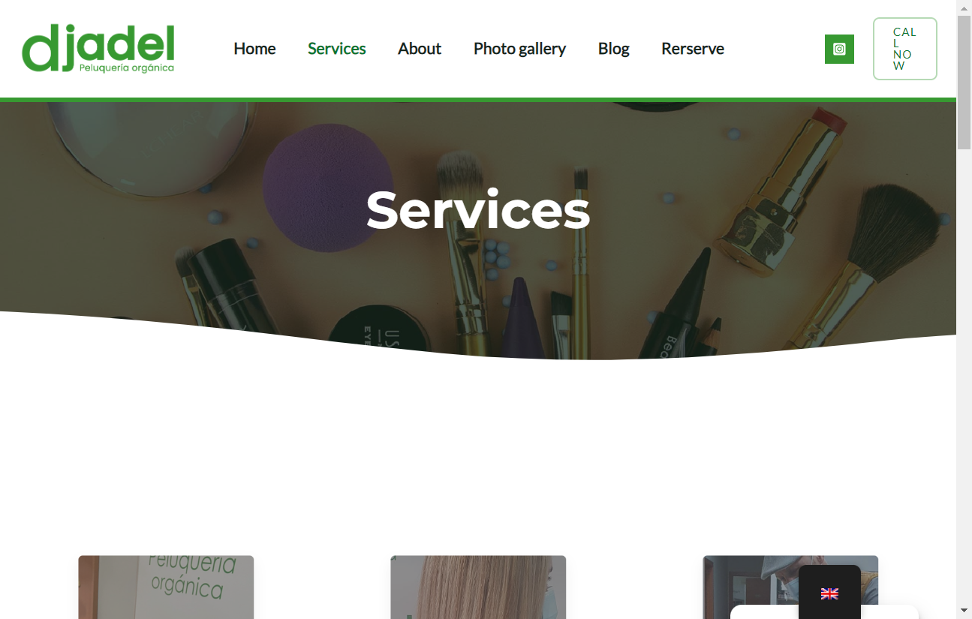

Contact - Djadel Hairdresser  
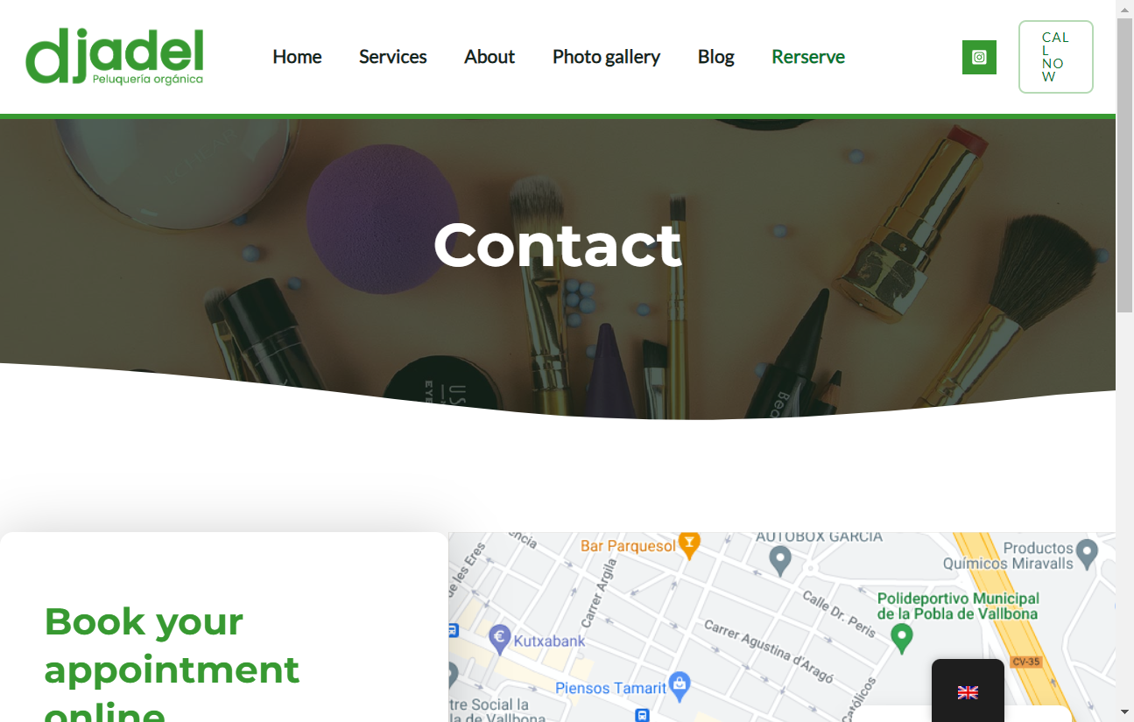

Privacy policy - Djadel Peluquería  
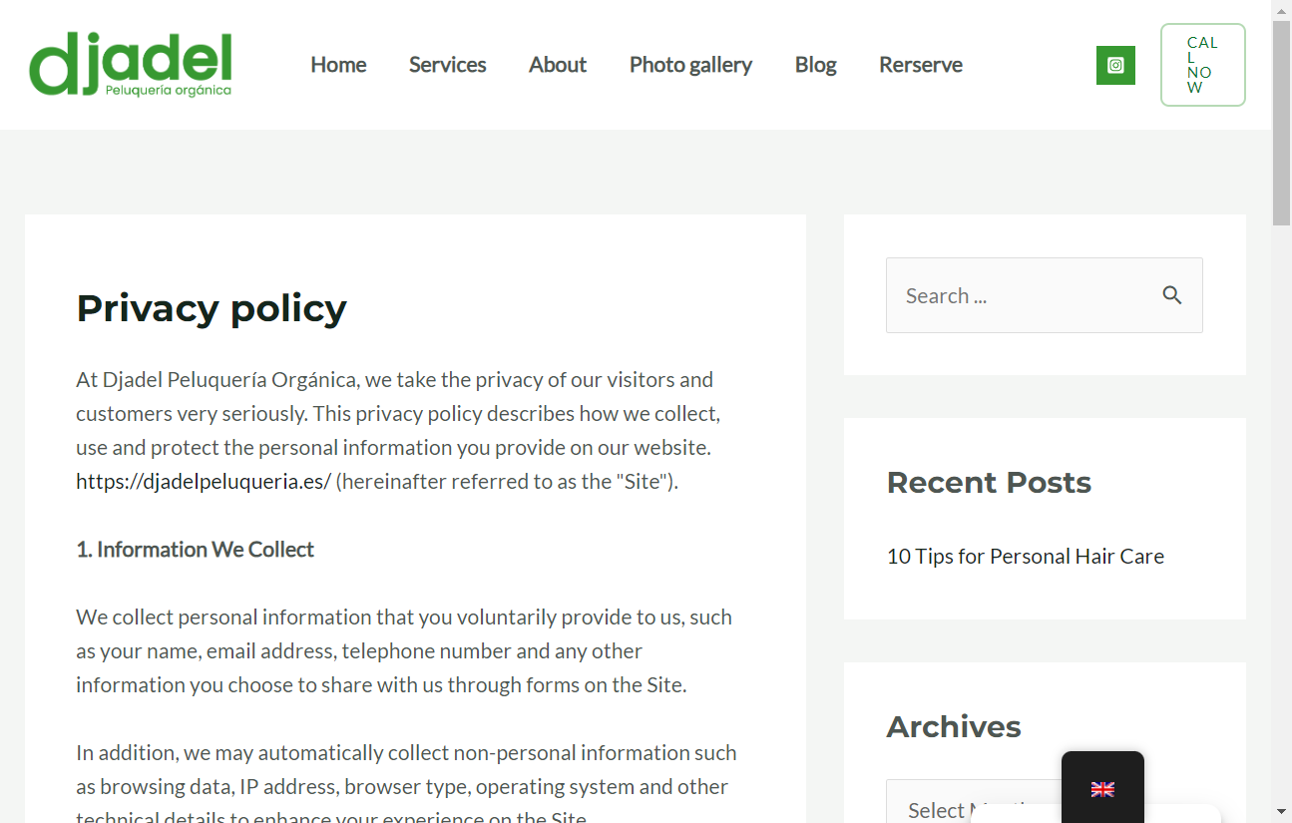

Photo gallery - Djadel Hairdressing Salon  
